

**Product Dissection for DREAM11**

### **Company Overview:**

Dream11,founded in 2008 by Harsh Jain and Bhavit Sheth is a leading fantasy sports platform that revolutionises the way sports enthusiasts engage with their favourite games. It allows users to create virtual teams by selecting real-life players and compete against others in various skill-based contests. With a vast array of sports, including cricket, football, kabaddi, and more, Dream11 offers an immersive and interactive experience. Users can showcase their sports knowledge, strategize team selections, and win exciting cash prizes. Through its user-friendly interface, social features, and data-driven insights, Dream11 has redefined the sports viewing experience, fostering a vibrant community of passionate fans.

### **Product Dissection and Real-World Problems Solved by DREAM11:**

Here is a product dissection for Dream11, highlighting how it addresses real-world challenges through its innovative features:

Dream11, a pioneering fantasy sports platform, has effectively addressed real-world challenges faced by sports enthusiasts worldwide. At its core, Dream11 solves the problem of enhancing the sports viewing experience by allowing users to actively participate and engage with live matches. Through its virtual team creation feature, Dream11 empowers users to showcase their sports knowledge by strategically selecting players, fostering a skill-based gaming experience that transcends passive viewership.

Dream11's platform addresses the need for monetizing sports expertise by offering cash-based contests and prize pools. Users can leverage their knowledge and analytical skills to create successful virtual teams and potentially earn financial rewards, solving the challenge of turning their passion for sports into a lucrative pursuit.

Moreover, Dream11 has addressed the need for a vibrant sports community by incorporating social features that enable users to interact, discuss strategies, and share their experiences. This social aspect fosters a sense of belonging and camaraderie among users with similar interests, solving the problem of isolation often faced by sports fans.

Dream11's diverse range of contests, encompassing various sports disciplines, addresses the challenge of limited engagement opportunities for niche sports. By offering contests and leagues for lesser-known sports, Dream11 has increased awareness, exposure, and fan engagement, potentially leading to the growth and popularisation of these sports.

Furthermore, Dream11 tackles the challenge of accessibility by providing a user-friendly mobile-first platform, allowing users to engage with their favourite sports anytime and anywhere. This convenience factor addresses the real-world problem of limited access to sports engagement opportunities, especially for individuals with busy lifestyles or geographical constraints.

Dream11's data-driven approach also addresses the challenge of fan insights and analytics. By collecting and analysing user data, Dream11 can provide valuable insights into fan behaviour, preferences, and trends. These insights can be leveraged by sports organisations, broadcasters, and stakeholders to make informed decisions and enhance their offerings, ultimately addressing the need for a more tailored and engaging sports experience.

In conclusion, Dream11's innovative product offerings have successfully addressed real-world challenges faced by sports enthusiasts by enhancing the viewing experience, enabling skill-based gaming, fostering a vibrant community, popularising niche sports, ensuring accessibility, and providing data-driven insights. Through its diverse features and user-centric approach, Dream11 has redefined the way fans engage with and experience their favourite sports.

### **Case Study: Real-World Problems and DREAM11’s Innovative Solutions**

#### **Problem 1: Enhancing the Sports Viewing Experience:**

**Real-World Challenge:** It involves addressing the passive nature of traditional spectatorship,where viewer simply watch event without active engagement

**DREAM11’s Solution:** Dream11 allows users to actively engage with live sports matches by creating virtual teams and competing against other users. This adds an extra layer of excitement and involvement, making the sports viewing experience more interactive and engaging.

#### **Problem 2: Providing a Platform for Skill-based Gaming**

**Real-World Challenge:** a decade back there is no platform for the sports lover to showcase their talent after analyzing the sports

**DREAM11’s Solution:** Dream11 offers a skill-based gaming platform where users can showcase their knowledge and understanding of sports by strategically selecting players their virtual teams. This caters to the desire for competitive gaming experiences based on skill rather than pure luck.

#### **Problem 3: Monetizing Sports Knowledge:**

**Real-World Challenge:** Many individuals aspire to pursue creative endeavours, but finding a platform to showcase and monetize their talents can be daunting.

**DREAM11's Solution:**

Dream11 enables users to monetize their sports knowledge and expertise. By participating in various contests and creating successful virtual teams, users can win cash prizes, providing an opportunity to earn while enjoying their passion for sports.

#### **Problem 4: Popularizing Niche Sports**

**Real-World Challenge:** Before this come most of the spectator wants to see their favourite sports or very popular sports so rest of the sports being aside

**DREAM11's Solution:**

Dream11 has helped popularize and increase awareness of niche sports by offering contests and leagues for various sports disciplines. This exposure can potentially lead to increased viewership, fan engagement, and overall growth of these sports.

#### **Conclusion:**

Dream11 has transformed the sports viewing experience by offering an immersive fantasy sports platform that combines skill, strategy, and competition. By enabling users to create virtual teams and compete in contests, Dream11 addresses the need for interactive engagement and monetizing sports expertise. Its vibrant community fosters meaningful connections among passionate fans, while increasing exposure for niche sports. With a user-friendly interface, data-driven insights, and mobile accessibility, Dream11 solves real-world challenges, empowering sports organizations and stakeholders to enhance their offerings. As a game-changer in the industry, Dream11's innovative solutions have redefined how fans experience and interact with their favourite sports.

### **Top Features of DREAM11:**

1. **Virtual Team Creation:** The core feature of Dream11 allows users to create their own virtual teams by selecting real-life players from upcoming matches across various sports.
2. **Diverse Range of Contests:** Dream11 offers a wide range of contests, including head-to-head, league-based, and multi-entry contests, catering to different preferences and skill levels.
3. **Cash Prizes and Winnings**: Users have the opportunity to win substantial cash prizes by participating in paid contests, monetizing their sports knowledge and strategic skills.
4. **Multi-Sport Support:** Dream11 supports a variety of sports, including cricket, football, basketball, kabaddi, and more, providing a comprehensive fantasy sports experience.
5. **User-Friendly Interface:** Dream11's intuitive and user-friendly interface, optimized for mobile devices, ensures a seamless experience for users to create teams, join contests, and track their performance.
6. **Safe and Secure Transactions:** Dream11 offers secure payment gateways and wallet management systems, ensuring safe and hassle-free financial transactions for users.

1. **Personalized Recommendations:** Dream11 utilizes data-driven algorithms to provide personalized recommendations for contests, players, and teams based on users' preferences and past performance.

### **Schema Description:**

The schema covers the core entities and relationships required for DREAM11 fantasy sport platform,including users,sports,matches,players,user teams,contest,contest entries,and transactions.The tables are connected through various foreign key relationships to maintain data integrity and facilitate efficient data retrieval and manipulation.

**User Entity:**

Users sign up for DREAM11. The user entity contains information about each user:

* **user_id (Primary Key)**: A unique identifier for each user.
* **Username**: The chosen username for the user's account.
* **Email**: The user's email address for account-related communication.
* **password**: A string storing the user's password
* **profile_picture**: A string that can store the URL of the user's profile picture
* **date_of_birth**:A date representing the user's date of birth.
* **gender**:A single character representing the user's gender.
* **phone_number**:A string that can store the user's phone number.
* **address**:A string that can store the user's address.
* **wallet_balance**:A decimal value representing the user's current wallet balance, with a precision of 10 digits and 2 decimal places. The default value is set to 0.

**Sports Entity:**

Various sport user can play on the platform:

* **sport_id (Primary Key):** A unique identifier for each sport.
* **sporty_name**: A unique string representing the name of the sport.
* **sport_description**: A text field that can store a description of the sport.
* **sport_icon**: A string that can store the URL or file path of the sport's icon.

**Matches Entity:**

Matches happening on that day where user is playing:

* **match_id (Primary Key)**: A unique identifier for each match.
* **sport_id (Foreign Key referencing Sports Entity): An integer value referencing the sport_id from the Sports table, establishing a foreign key relationship.**
* **match_name**: A string representing the name of the match
* **match_date**: date representing date of a match
* **match_time**: time representing scheduled time of a match.
* **venue**:A string that can store the venue of the match.
* **team_1:**A string representing the name of one of the team.
* **team_2**:A string representing the name of one of the other team.
* **match_status**:A string indicating the current status of the match (e.g., "upcoming," "live," "completed")

**Players Entity:**

Players representing the teams for that matchday:

* **player_id (Primary Key):** A unique identifier for each player.
* **player_name:** The name of the player.
* **sport_id (Foreign Key referencing sports Entity):** An integer value referencing the sport_id from the Sports table, establishing a foreign key relationship.
* **team:** A string representing the team of the player.
* **player_image**:A string that can store the URL or file path of the player's image.
* **player_stats**:A JSON field that can store various performance statistics of the player.

**Users_Teams Entity:**

The team which users had made on that matchday:

* **user_team_id (Primary Key)**: A unique identifier for each user team.
* **user_id(Foreign Key referencing User Entity)**: An integer value referencing the user_id from the Users table, establishing a foreign key relationship.
* **match_id (Foreign Key referencing Matches Entity)**: An integer value referencing the match_id from the Matches table, establishing a foreign key relationship.
* **team_name**: A string representing the name of the user's team.
* **Players (Foreign Key referencing Players Entity)**: An array of integer values representing the player_id values from the Players table, indicating the players selected for the user's team.
* **total_points**:An integer value representing the total points scored by the user's team. The default value is set to 0.

**Contests Entity:**

Contests running on that matchday on the platform:

* **contest_id (Primary Key):** unique identifier for each contest.
* **Match_id (Foreign Key referencing Matches Entity)**: An integer value referencing the match_id from the Matches table, establishing a foreign key relationship.
* **contest_name**:A string representing the name of the contest
* **contest_type**:A string representing the type of contest (e.g., "head-to-head," "multi-entry")
* **entry_fee**:A decimal value representing the entry fee for the contest, with a precision of 10 digits and 2 decimal places.
* **total_prize_pool**:A decimal value representing the total prize pool for the contest, with a precision of 10 digits and 2 decimal places.
* **prize_distribution**:A JSON field that can store the prize distribution details for the contest.

**Contest_Entries Entity:**

Entries for that contests on the platform:

* **entry_id (Primary Key)**: unique identifier for each contest entry
* **user_id(Foreign Key referencing User Entity)**: An integer value referencing the user_id from the Users table, establishing a foreign key relationship.
* **contest_id(Foreign Key referencing Contests Entity)**: An integer value referencing the contest_id from the Contests table, establishing a foreign key relationship.
* **user_team_id(Foreign Key referencing User_Teams Entity)**: An integer value referencing the user_team_id from the User_Teams table, establishing a foreign key relationship.
* **entry_status**:A string representing the current status of the contest entry (e.g., "joined," "not joined," "won," "lost")
* **prize_won**:A decimal value representing the prize won by the user for the contest entry, with a precision of 10 digits and 2 decimal places. The default value is set to 0.

**Transactions Entity:**

All the transactions occurred during playing the contests.

* **transaction_id**:A unique identifier for each transaction.
* **user_id(Foreign Key referencing User Entity)**:An integer value referencing the user_id from the Users table, establishing a foreign key relationship.
* **transaction_type**:A string representing the type of transaction (e.g., "credit," "debit")
* **amount**:A decimal value representing the amount of the transaction, with a precision of 10 digits and 2 decimal places.
* **transaction_date**:A timestamp value representing the date and time of the transaction. The default value is set to the current timestamp using the current_timestamp function.

**transaction_details**:A text field that can store details or descriptions related to the transaction.

**Relationships are:**

**In the given schema for the Dream11 fantasy sports platform, there are several relationships established between the tables using foreign key constraints. Here are the relationships:**

**1. Sports and Matches:**

- The `Matches` table has a foreign key constraint `sport_id` that references the `sport_id` column in the `Sports` table.

- This establishes a one-to-many relationship, where one sport can have multiple matches, but each match belongs to only one sport.

**2. Sports and Players:**

- The `Players` table has a foreign key constraint `sport_id` that references the `sport_id` column in the `Sports` table.

- This establishes a one-to-many relationship, where one sport can have multiple players, but each player belongs to only one sport.

**3. Users and User_Teams:**

- The `User_Teams` table has a foreign key constraint `user_id` that references the `user_id` column in the `Users` table.

- This establishes a one-to-many relationship, where one user can create multiple teams, but each team belongs to only one user.

**4. Matches and User_Teams:**

- The `User_Teams` table has a foreign key constraint `match_id` that references the `match_id` column in the `Matches` table.

- This establishes a one-to-many relationship, where one match can have multiple user teams created for it, but each user team is associated with only one match.

**5. Users and Contest_Entries:**

- The `Contest_Entries` table has a foreign key constraint `user_id` that references the `user_id` column in the `Users` table.

- This establishes a one-to-many relationship, where one user can have multiple contest entries, but each contest entry belongs to only one user.

**6. Contests and Contest_Entries:**

- The `Contest_Entries` table has a foreign key constraint `contest_id` that references the `contest_id` column in the `Contests` table.

- This establishes a one-to-many relationship, where one contest can have multiple entries, but each entry belongs to only one contest.

**7. User_Teams and Contest_Entries:**

- The `Contest_Entries` table has a foreign key constraint `user_team_id` that references the `user_team_id` column in the `User_Teams` table.

- This establishes a one-to-many relationship, where one user team can be entered into multiple contests, but each contest entry is associated with only one user team.

**8. Users and Transactions:**

- The `Transactions` table has a foreign key constraint `user_id` that references the `user_id` column in the `Users` table.

- This establishes a one-to-many relationship, where one user can have multiple transactions, but each transaction belongs to only one user.

**These relationships ensure data integrity and enable efficient data retrieval and manipulation by establishing connections between the different entities in the Dream11 fantasy sports platform.**

**ER Diagram:**

Let's construct an ER diagram that vividly portrays the relationships and attributes of the entities within the Instagram schema. This ER diagram will serve as a visual representation, shedding light on the pivotal components of DREAM11’s data model. By employing this diagram, you'll gain a clearer grasp of the intricate interactions and connections that define the platform's dynamics.

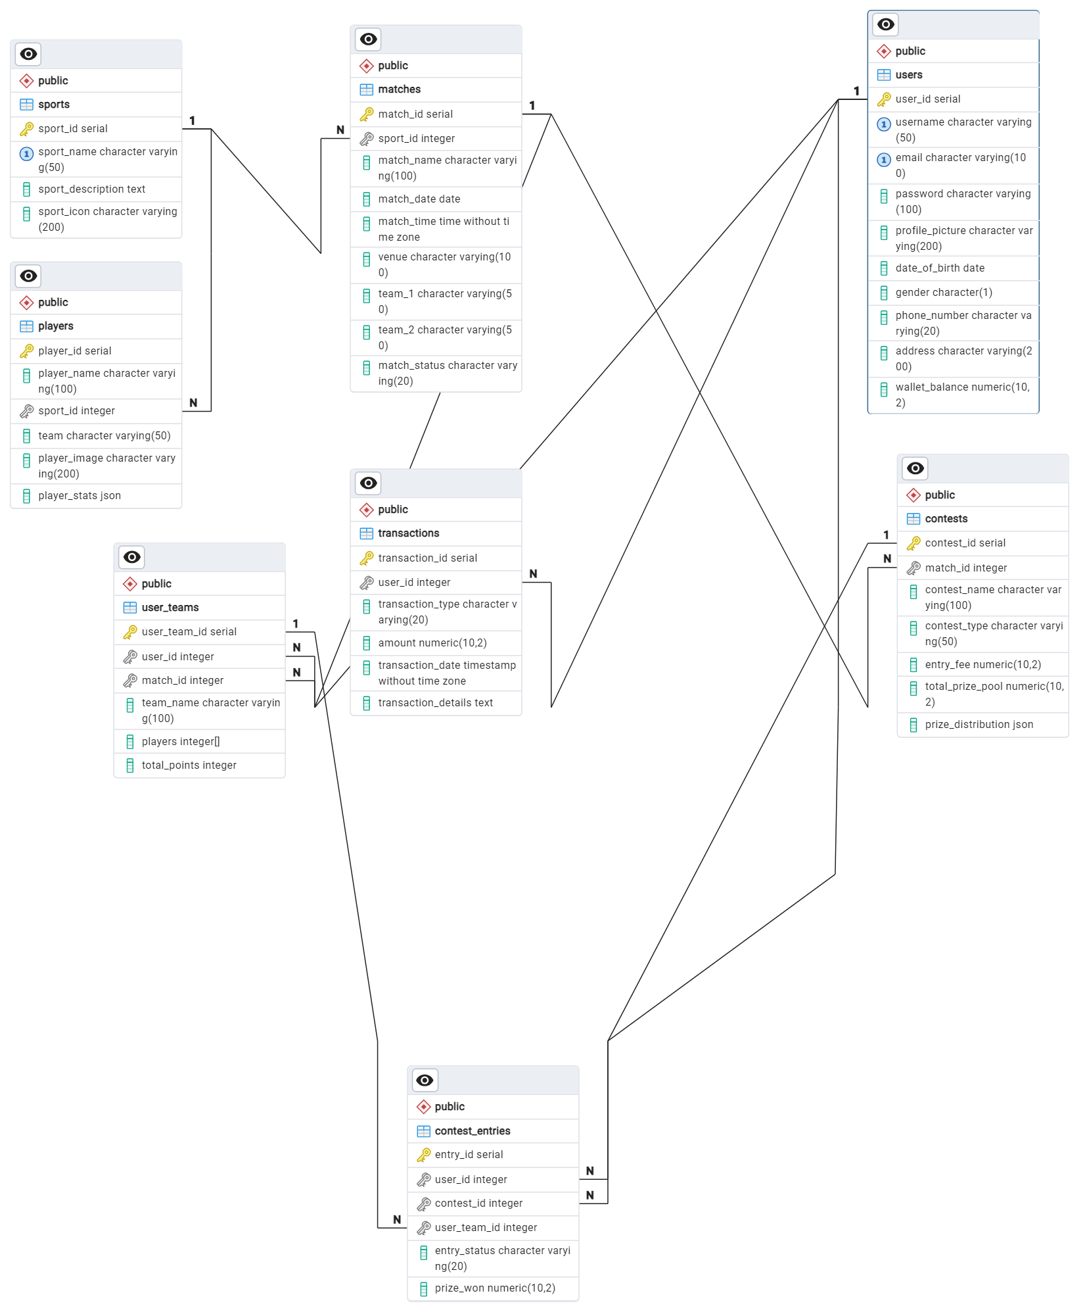

### **Conclusion**

The Dream11 schema and its entity-relationship design provide a robust foundation for the platform's engaging fantasy sports experience. At its core, the Users entity enables user profiles, authentication, and financial transactions. Sports, Matches, and Players capture essential details, while User_Teams facilitates virtual team creation. The Contests and Contest_Entries entities handle contest management, entry fees, prize pools, and user participation tracking. The Transactions entity ensures secure financial operations. Relationships established through foreign key constraints maintain data integrity and efficient data retrieval. One-to-many relationships between Users, User_Teams, and Contest_Entries enable effective management of user-specific data. The schema accommodates diverse features, fostering social interactions, personalized recommendations, and data-driven analytics. By meticulously designing this schema, Dream11 has laid the groundwork for seamless user experiences, efficient data management, and scalability to accommodate future growth in the fantasy sports industry.